Pothole Tracking and Repair System (PHTRS)
Mahmudul Alam
Colorado State University Global
20WA-CSC505-1
Monday, December 21, 2020

Roads are an important part of our modern civilization. We conduct our daily commute and business using roads. Potholes in the road can cause serious damage to the people and cause damage to the economy by causing accidents and delays. Potholes can damage to the tire and wheels, and lower part of a vehicle. By improving roads, we can improve economical growth and have safer travels. Solving the problem first requires detecting the problem, there are many methods which are in experimental phase for dealing with pothole.
Throughout the world every country is dealing with the problem of road conditions caused by potholes. Third world nation countries are suffering more from this problem. “Despite of application of modem materials and methods for construction and repair of asphalt and concrete road pavement, the problem pertaining to removal of surface defects and consequently requirement for effective pothole repairing methods still remains an actual one and it is considered as one of the factors that ensures safety traffic conditions.” ( A. Yu. Igoshkina) it is a growing concern around the world detecting potholes and repairing them. Detecting potholes is one of important aspect of keeping the roads safer, manually detecting evaluating potholes are expensive and time consuming.
Pothole detection methods are divided into three categories. Vibration based detection, 3d reconstruction-based method and vision-based method. “Vibration-based damage detection (VBDD) methods use damage-induced changes to the dynamic properties of a structure to detect, locate, and sometimes quantify the extent of damage.”( Zhou) The development of three-dimensional models from a collection of images is the reconstruction of 3D from multiple images. It is the reverse mechanism by which 3D scenes receive 2D images. The nature of an image is a projection onto a 2D plane from a 3D picture, during which the depth is lost. Computer vision also relies on assumptions about the scene portrayed in a picture that are less complex. Computer vision and 3d reconstruction together can be effective finding potholes and can be implemented in a system to detect and repair. Finding the potholes are the first step towards the solution. We can sure develop systems that uses video of the roads to automatically detect potholes, 3d reconstruction and other methods but involving every citizen in the system can be effective way of finding the ultimate solution. Considering the scenario building a web-based application for daily users to record potholes brings in many factors. Being able to identify the location of the issue, the size and shape of the pothole, also that information can be provided to the higher authority for repair purposes.
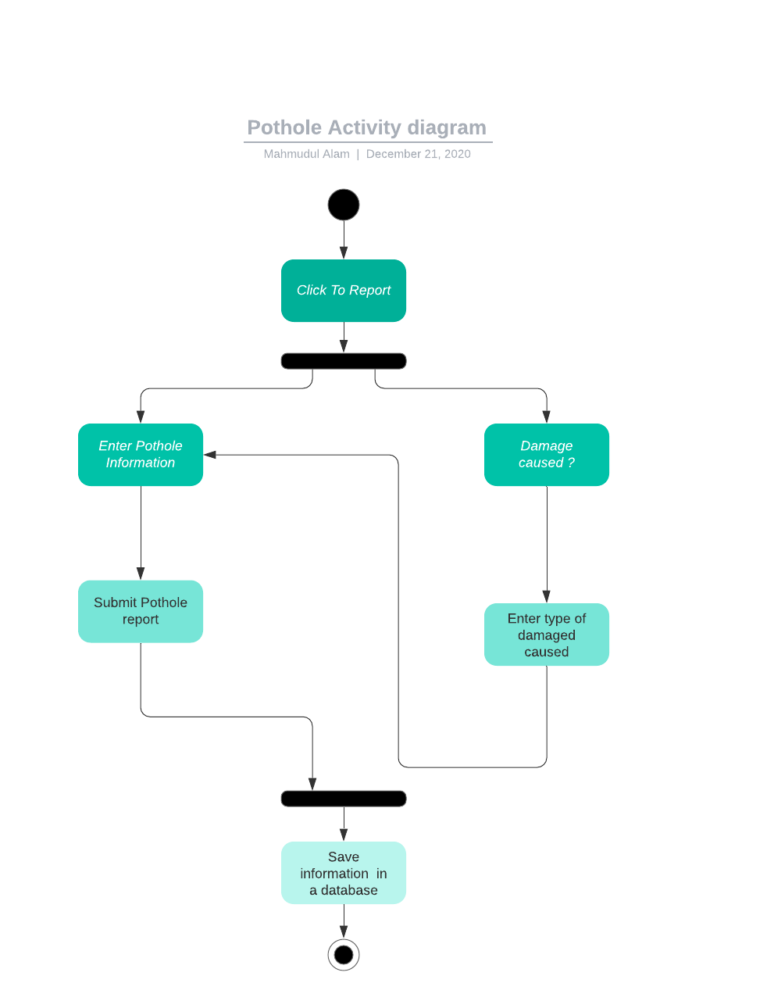

Use case scenario for the systems is as follows:
Use case: Reporting a Pothole
Primary Actor: All the people/ citizen of the country
Goal in Context: A pothole can report and damaged caused by the pothole can also be recorded.
Tigger: When someone sees a pothole or experiences it and thinks that should be reported and recorded, they can input the information.
Scenario:
- Once the user lodes the page there will be a clickable link to report.
- There will be option available displaying location for user input.
- When the user wants to report a damage, they need to input their personal information.
- There will be option to click next on each phase of the form.
- User will fill out all the information, the user will submit button when they are done inputting all the information
- Once the user submits the report it will be saved to a database and administrative people will be able to access and analyze the data.

References

A. Yu. Igoshkina. Stock-Piled Organic and Mineral Mixtures for Pot-Hole Repairing of Asphalt
and Concrete Pavements. Nauka i Tehnika. 2017;(2):15-19. doi:10.21122/2227-1031-
2007-0-2-15-19
Zhou, Z., &amp; L. W. (2007, September 07). Journal of Structural Engineering. Retrieved from
https://doi.org/10.1061/(ASCE)0733-9445(2007)133:9(1257)

